

Subscribe to DeepL Pro to edit this document.  
Visit www.DeepL.com/Pro for more information.

**The rules of chess**

Chess is a game played by two players. One player plays with the white pieces and the other player plays with the black pieces. Each player has sixteen pieces at the beginning of the game: a king, a lady (also called: queen), two rooks, two bishops, two knights and eight pawns.

The game is played on a chessboard. The chessboard has 64 fields: eight rows and eight columns. The fields are alternately colored light (white) and dark (black). The board must be laid out so that there is a black field in the lower left corner. In order to record moves, all fields have been given names. As seen from the white player's point of view, the rows are numbered 1, 2, 3, 4, 5, 6, 7, 8; the bottom row (on white's side) is numbered 1, and the top row is numbered 8. The columns (again, seen from white) are named (from left to right) a, b, c, d, e, f, g, h. The name of a square consists of the combination of the letter of its column and the number of its row; for example, the square in the lower left corner (for white) is named a1.

black

white

The players take turns making a move, starting with the white player (the player playing with the white pieces). A move consists of moving one of the player's pieces to another square, according to the rules that say how that piece moves. There is a special exception, which is the **castling**, where in one move two pieces are moved at the same time.

A player can **capture** an opponent's piece by moving one of his own pieces to the square that contains an opponent's piece. The opponent's piece is then removed from the board, and is out of play for the rest of the game. Capturing is not mandatory.

At the start of the game, the arrangement of the pieces is as follows.

So on the second row there are eight white pawns; on the seventh row there are eight black pawns. On the first row, from left to right, there are: a rook, knight, bishop, lady, king, bishop, knight and rook. Note that in the initial setup, ladies stand on squares of their own color (the white lady stands on a white square and the black lady stands on a black square), and each player has a black square in the lower left corner.

**Course of the pieces**

**Tower**

The tower moves in a straight horizontal or vertical line. The tower may not jump over other pieces, i.e.: all squares between the square where the tower begins its move and where the tower ends its move must be empty. (As with all pieces, if the square where the rook ends its move contains an opponent's piece, this piece is captured. The square where the rook ends its move must not contain a piece belonging to the player who also has this tower).

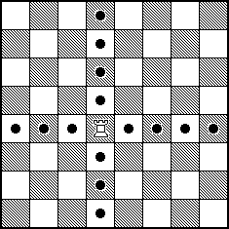

**Runner**

The bishop moves in a straight diagonal line. The runner may also not jump over other pieces.

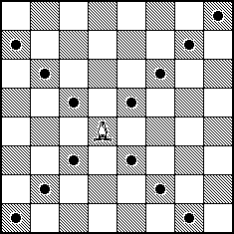

**Lady**

The lady has the *combined* capabilities of the rook and bishop, i.e., the lady can move in a horizontal, vertical or diagonal straight line. Again, the lady may not jump over other pieces. The queen is also called **queen**.

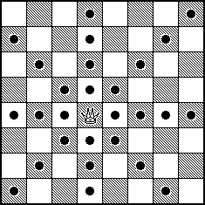

**Horse**

The horse makes a move that consists of first one step in a horizontal or vertical direction and then one step diagonally `outward'. The move can also be described as: two steps horizontally and one step vertically or two steps vertically and one step horizontally. The horse **jumps**: it is allowed that the square which the horse passes in its move contains any piece. For example, white can start the game by moving his knight from b1 to c3. Horses can jump over squares with a white piece, with a black piece, and also over empty squares. When a horse jumps over a piece, it has no effect on the piece being jumped over; as with the other pieces, a horse captures an opponent's piece by moving to the square containing that piece.

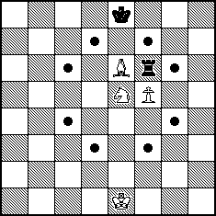

**Pawn**

The pawn's moves differ depending on whether the pawn moves to an empty square, or it captures an opponent's piece. When a pawn does not capture, it moves one step straight ahead. If a pawn has not yet run at all, i.e., the pawn is still on the second row (as seen from the player whose pawn it is), then the pawn may take a double step straight forward. For example, a pawn or d2 can be moved to d4, provided field d3 is empty.

The pawn strikes one space diagonally forward.

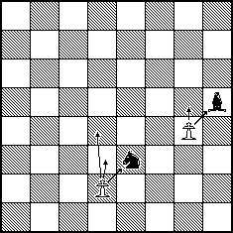

There is a special rule: the *en passant rule*. If a pawn makes a double move from the second to the fourth row, and there is an enemy pawn on an adjacent square in the fourth row, then in the next move this enemy pawn can move diagonally to the square that was skipped by the double-stepping pawn; thus, this square is on the third row. With this, the first pawn is considered captured, and the pawn is removed from the board.

Such an en passant capture move must be done immediately: if a player who can capture en passant does not do so in the first move after the double step, then that pawn cannot be captured by an en passant move.

A double step of a pawn, followed by en-passant striking

Pawns that reach the last row of the board *promote*. If a player moves a pawn to the last row of the board, he exchanges that pawn for a queen, rook, knight or bishop (of the same color). The new piece will be placed in the place of the promoted pawn. Usually players choose a lady, but it is also possible to take any other kind of piece. (It is not required that the pawn promotes to a piece that has already been captured. So it is possible, for example, that a player has two queens at some point).

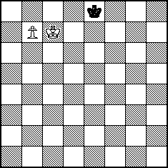 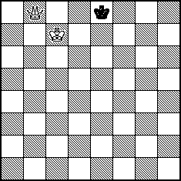

Before and after a promotion

**King**

The king moves a square in any direction: horizontally, vertically or diagonally. There is a special type of move, which is done by a king and a rook at the same time: the *Rokade* (see below).

The king is the most important time of the game, and one must never make moves so that the king *is in check* at the end of a move, zoe below.

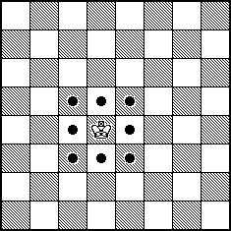

**Rokade**

If certain conditions are met, then the king and the rook can perform the *castling move*. This is a special kind of move, where both the king and the rook are moved.

Each of the following conditions must be met if a player wants to cast.

* The king doing the castling has not yet moved during the game.
* The rook doing the castling has not yet moved during the game.
* The king is not in check.
* The king does not cross a square that is attacked by an enemy piece during the castling; i.e., when a player casts, there must not be an opponent's piece that can move to (in the case of a pawn: by a diagonal move) a square that the king crosses.
* The king does not move to a square attacked by an enemy piece; i.e., the king may not be in check after the castling.
* All squares between the rook and the king are empty for the castling.
* The king and the rook are on the same row.

At the castling, the king moves two spaces in the direction of the rook, and the rook moves over the king to the next space. I.e., the white king on e1 and the rook on a1 go to: king c1, rook d1 (*long castling*), the white king on e1 and the white rook on d1 go to: king g1, rook f1 (*short castling*); similarly for black.